Vanier College

Computer Science Department

Web Services 420-551-VA Section 00002

Quality Assurance Report

Sports-api

Team leader: Uraib Ahmed Lakhani

Teacher: Sleiman Rabah

Dinal Patel

Craig Justin Balibalos

Jonathan Dimitriu

**Table Of Contents**

Problem description p. 3-16

**Team Member:** Justin

**Resource:** /sports

**Problem:** GET with invalid sport_name filter

**Screenshot:**

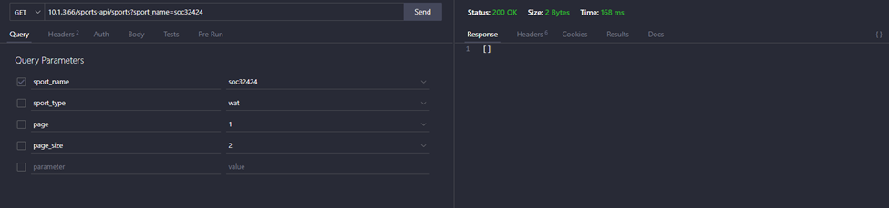

**Team Member:** Jonathan

**Resource:** /teams

**Problem:** GET with invalid ceo_name with all parameters.

**Screenshot:**

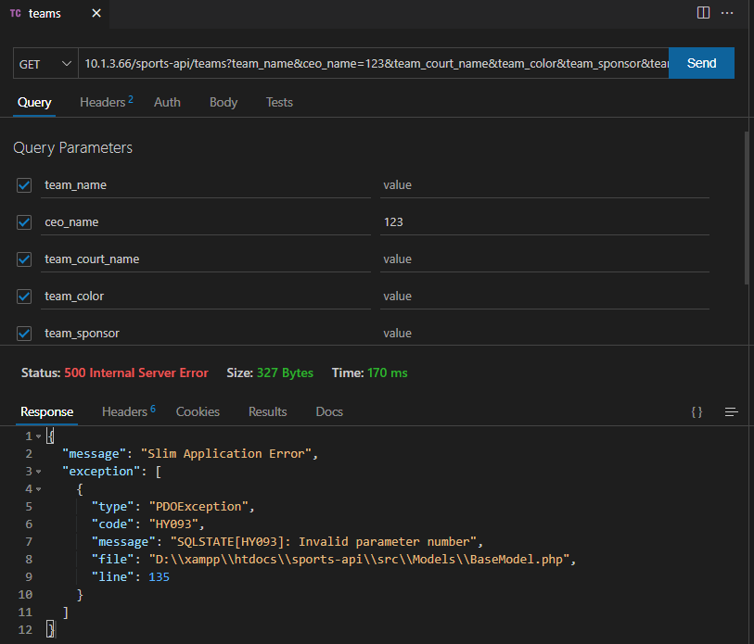

**Problem:** Get team_sponsor don’t work, can’t get all the sponsors

**Screenshot:**

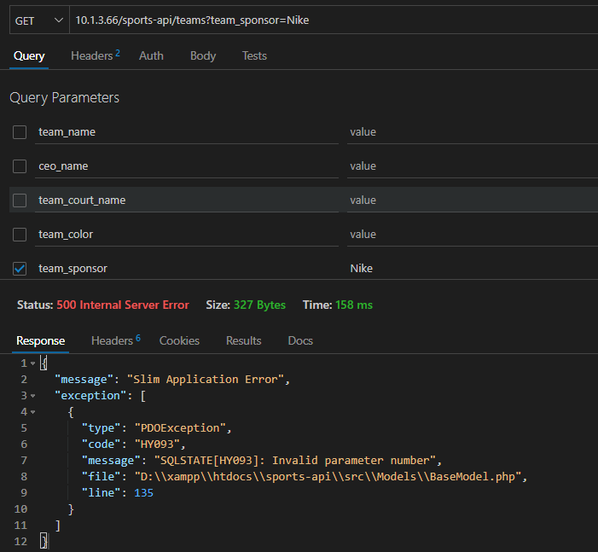

**Team Member:** Jonathan

**Resource:** /Players

**Problem:** POST with different type of data

**Screenshot:**

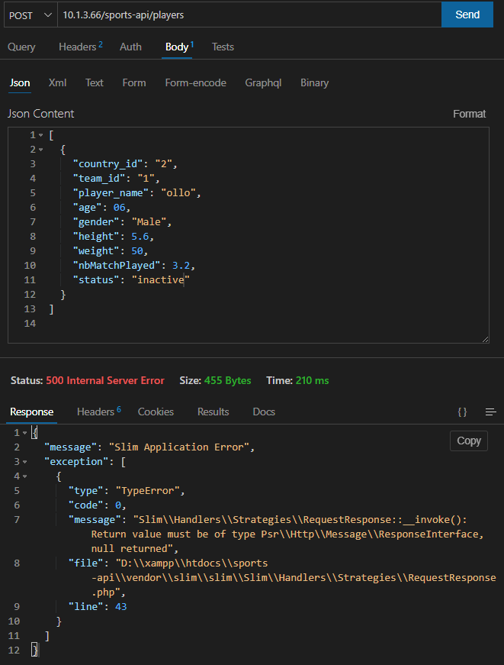

**Team Member:** Jonathan

**Resource:** /Teams

**Problem:** PUT with invalid ID still sends the data

**Screenshot:**

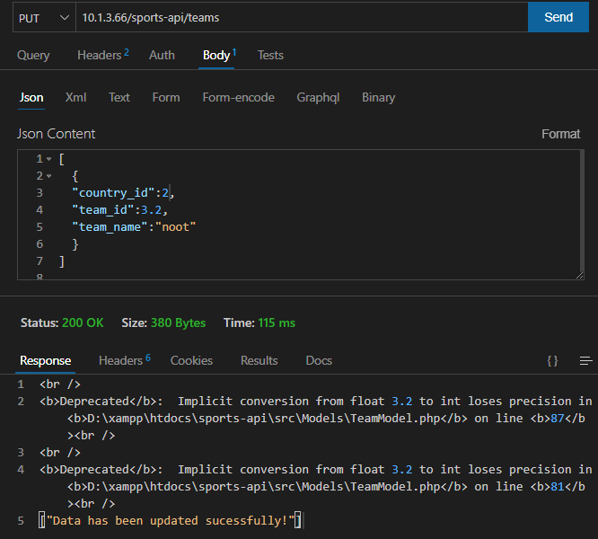

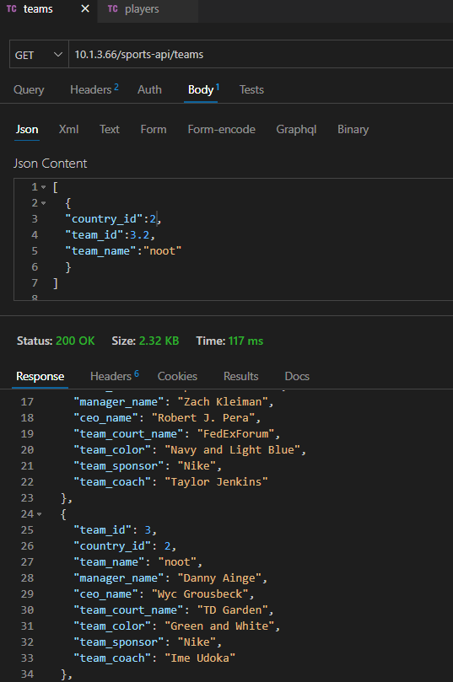

**Team Member:** Dinal

**Resource:** /rankings

**Problem:** DELETE not working, as shown in QA

**Screenshot:**

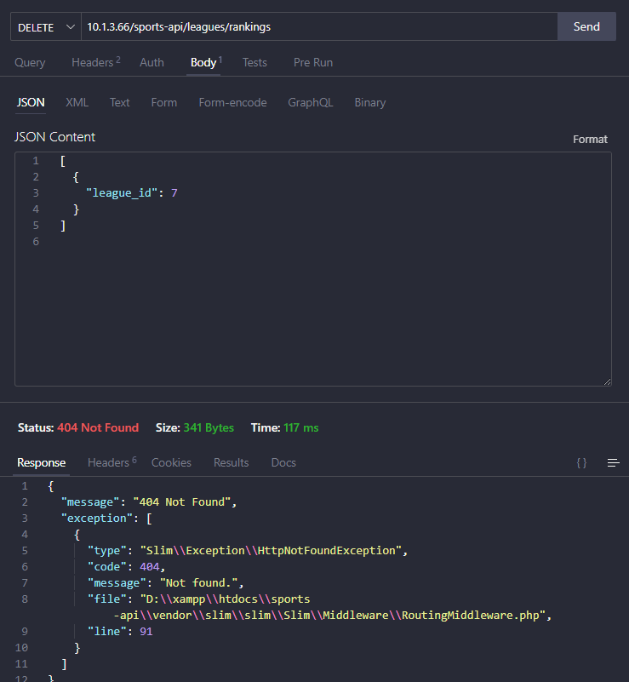

**Team Member:** Justin

**Resource:** /matches

**Problem:** GET with invalid stadium_name filter

**Screenshot:**

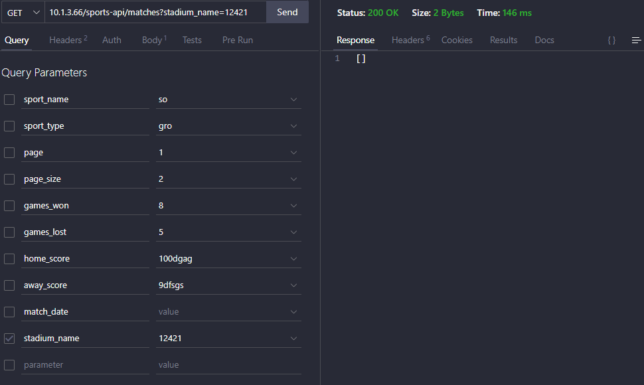

**Problem:** POST with empty body

**Screenshot:**

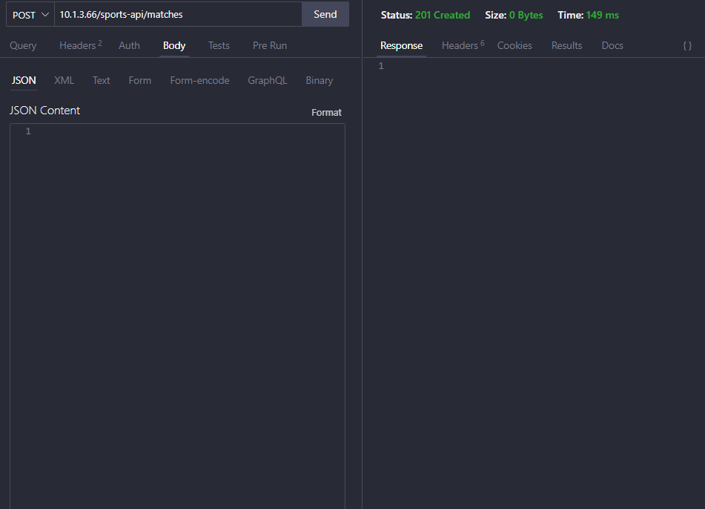

**Problem:** POST with invalid inputs in body

**Screenshot:**

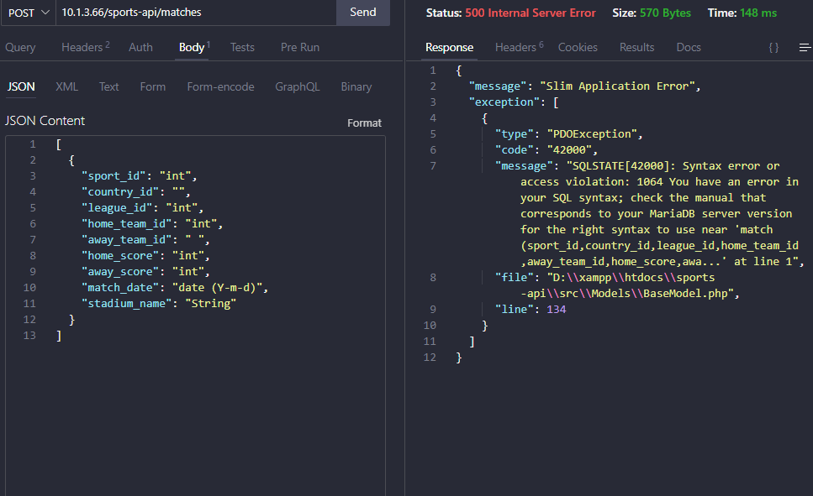

**Team Member:** Dinal

**Resource:** /league

**Problem:** GET nbOfTeams only accepts integer more than or equal to 3 but it only displays the record that starts with the specified value for nbOfTeams.

**Screenshot:**

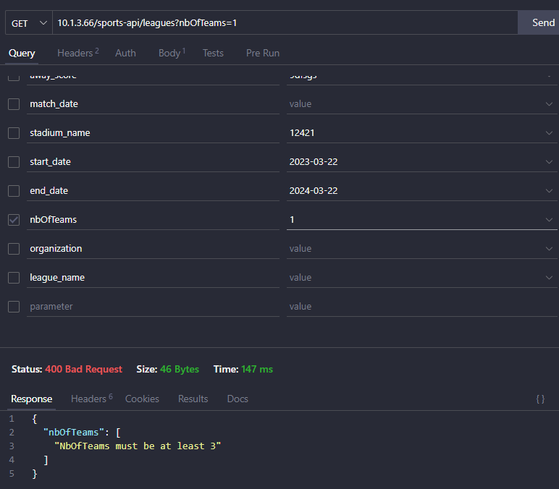

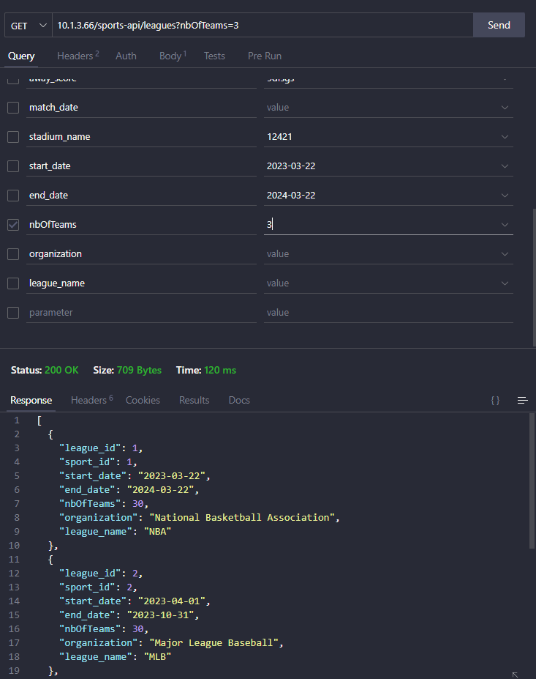

**Problem:** GET with invalid organization filter

**Screenshot:**

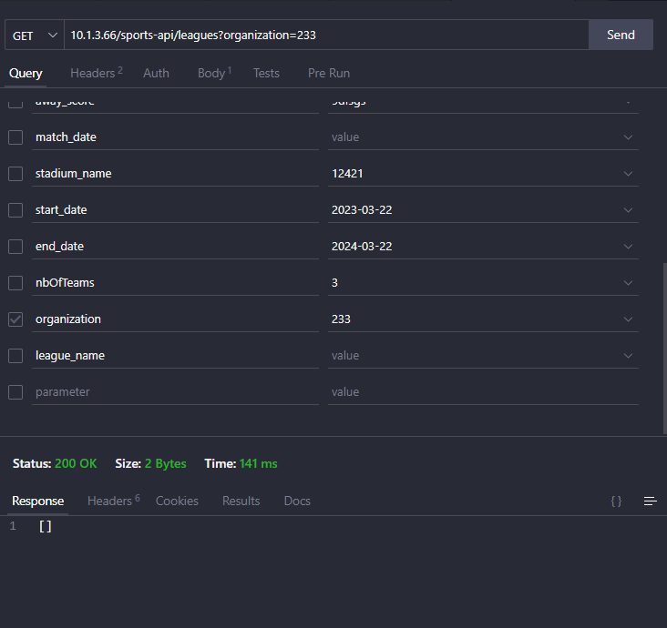

**Problem:** GET with invalid league_name filter

**Screenshot:**

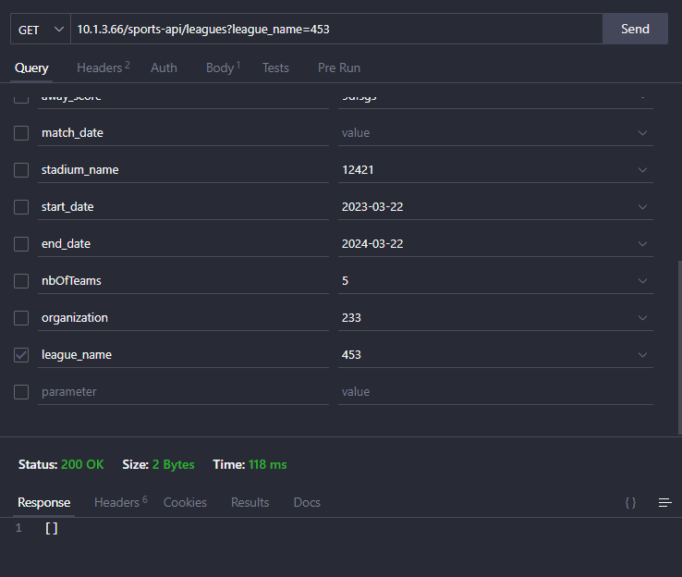

**Team Member:** Jonathan

**Resource:** /countries

**Problem:** POST Empty data still sends

**Screenshot:**

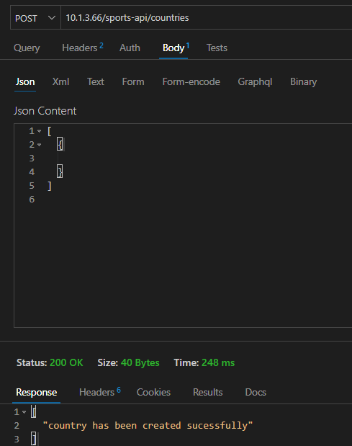

**Team Member:** Jonathan

**Resource:** /currency

**Problem:** POST shows accept Double but only takes INT

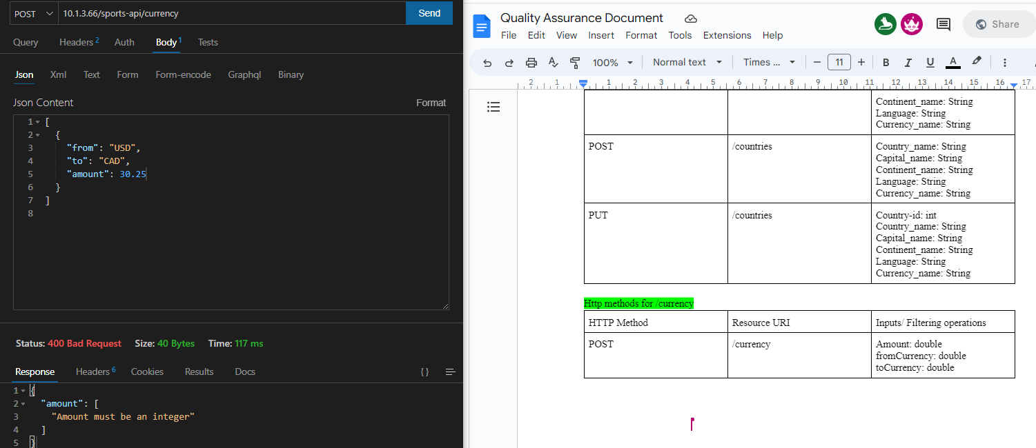

**Problem:** POST does not accept YEN to CAD + not matching error code

**Screenshot:**

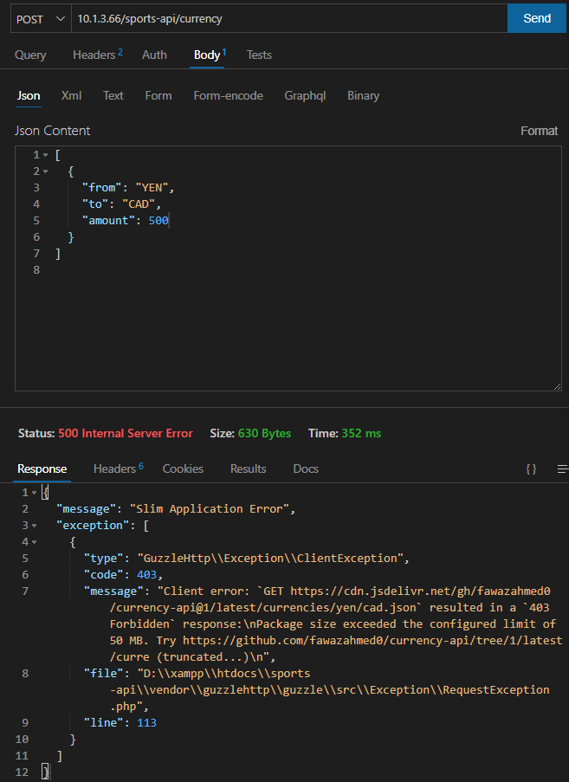

**Team Member:** Jonathan

**Resource:** /account

**Problem:** POST does not work there is pdo exception

**Screenshot:**

